**Select true or false. (Expect 10 to 20 questions following the format below)**

* 1. Miter lines are inclined at 45 degrees to the horizontal, and are used to sketch a third view form two views that are adjacent to each other. x pts.
     1. True
     2. False
  2. All 6 primary views are always needed. x pts.
     1. True
     2. False
  3. Because computers can automate processes, only the front view is needed. x pts.
     1. True
     2. False
  4. The number of views that are needed equals the number of features that the part has. x pts.
     1. True
     2. False
  5. x pts. Multiple choice. Select the correct answer (there is one correct answer only). Symmetry/Center lines are:
     1. Very thick solid lines.
     2. Dashed lines with styles that depend on the nature of the part under representation.
     3. Light dashed lines that are made of alternating long and short dashes.
     4. None of the above.
  6. 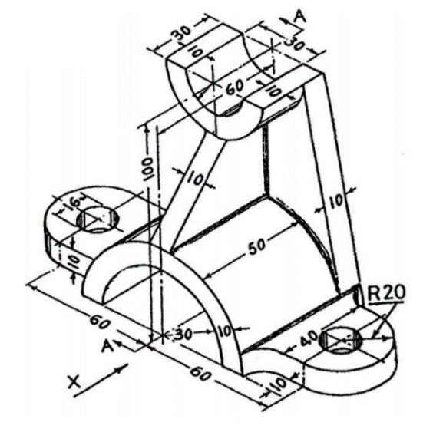5 pts. Multiple answer. Select the alternatives (one or more) that are true. In the following drawing, “x” marks the direction of sight of the front view. How many views should be sketched to fully represent the object using orthographic multiview projections? What views should these be?
     1. Three views, the front, top and right side views are sufficient.
     2. Three views, the front, rear and top, are sufficient and necessary.
     3. Three views, the front, top and left side views are sufficient.
     4. One view, the front, is sufficient and necessary.

1. Given the object below:
   1. How many orthographic (2D) projections are needed to completely represent the object? Answer: ____2_____ 5 pts
   2. Sketch the front and top views. Follow proportions. The slot is through thickness. 20 pts

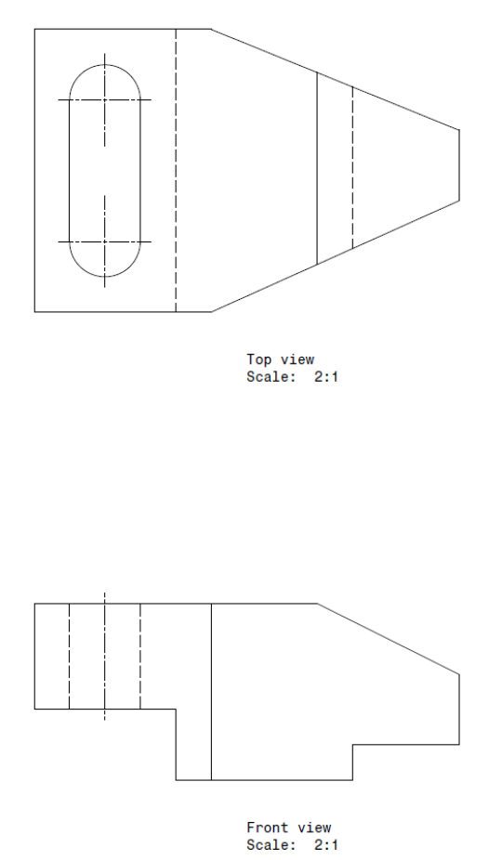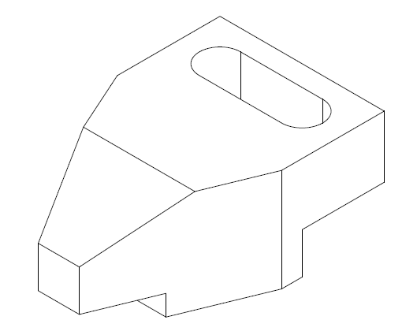

Front View



1. Given the object and the partially complete views below:
   * 1. Complete the views. 20 pts
     2. Is the right side view needed? ____No____5 pts

